1.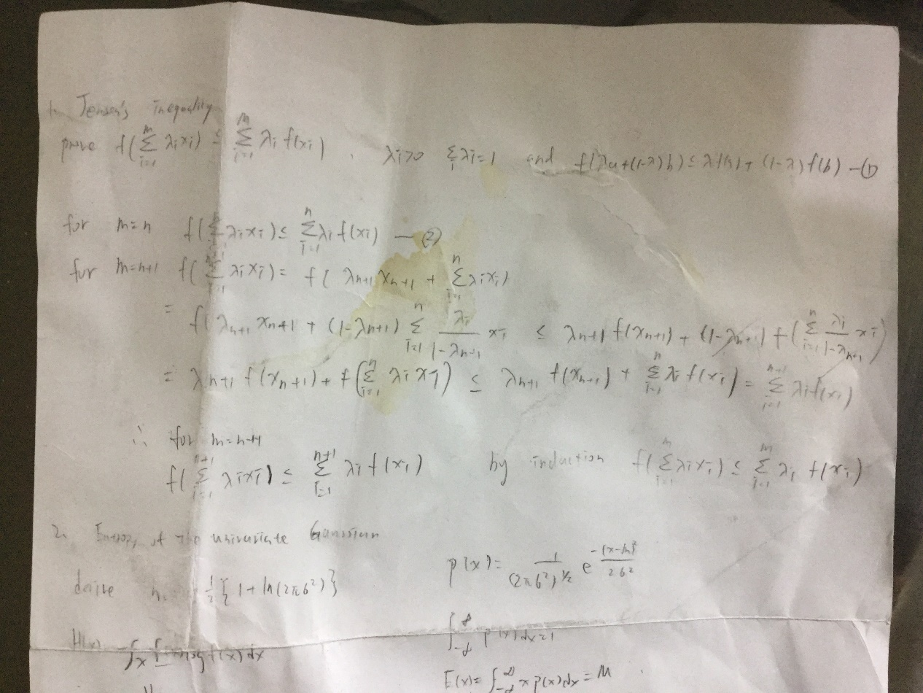

2.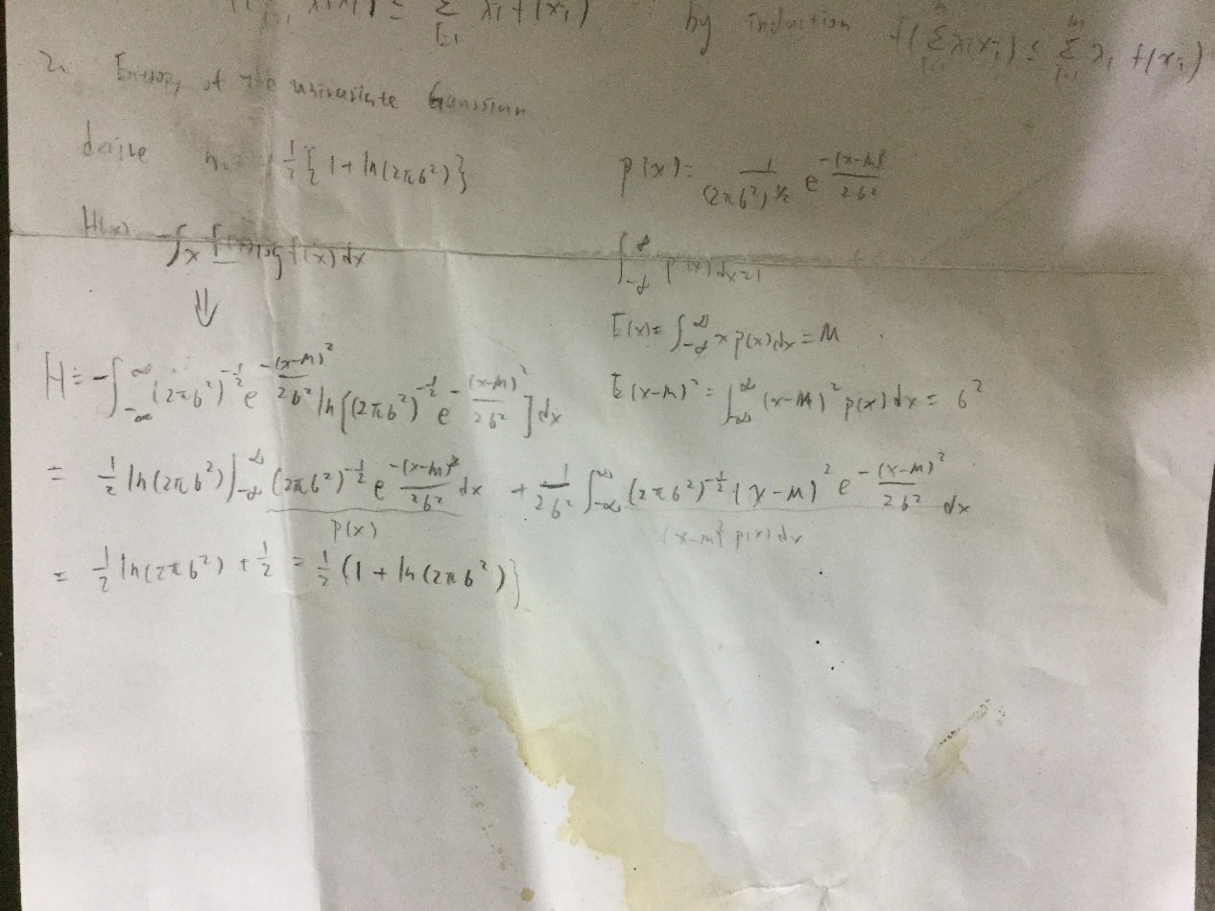

3.

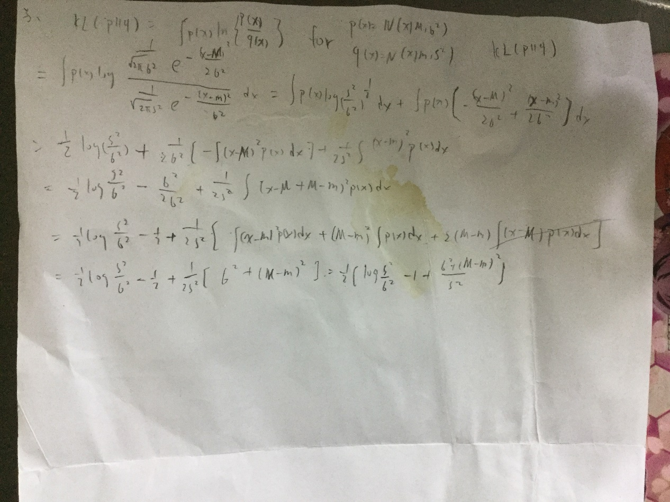

4.

(1)

Root-Mean-Square (RMS) error on the training set and test set

training set:

|  |  |  |  |  |  |  |  |  |
| --- | --- | --- | --- | --- | --- | --- | --- | --- |
| M=1 | M=2 | M=3 | M=4 | M=5 | M=6 | M=7 | M=8 | M=9 |
| 2.4363 | 2.0985 | 2.0943 | 2.0678 | 1.1191 | 1.1166 | 0.8365 | 0.8863 | 1.1683 |

test set:

|  |  |  |  |  |  |  |  |  |
| --- | --- | --- | --- | --- | --- | --- | --- | --- |
| M=1 | M=2 | M=3 | M=4 | M=5 | M=6 | M=7 | M=8 | M=9 |
| 2.5551 | 2.2724 | 2.2020 | 2.0834 | 1.2515 | 1.2172 | 1.5612 | 1.5513 | 1.7262 |

(2)

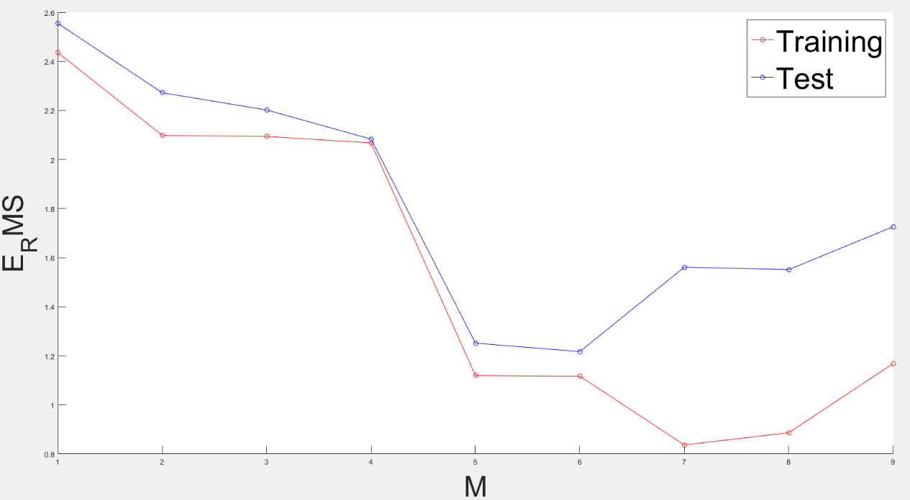

overfitting problem:

當m=7,8,9時 training error 太小，test error太大，造成overfitting

(3)

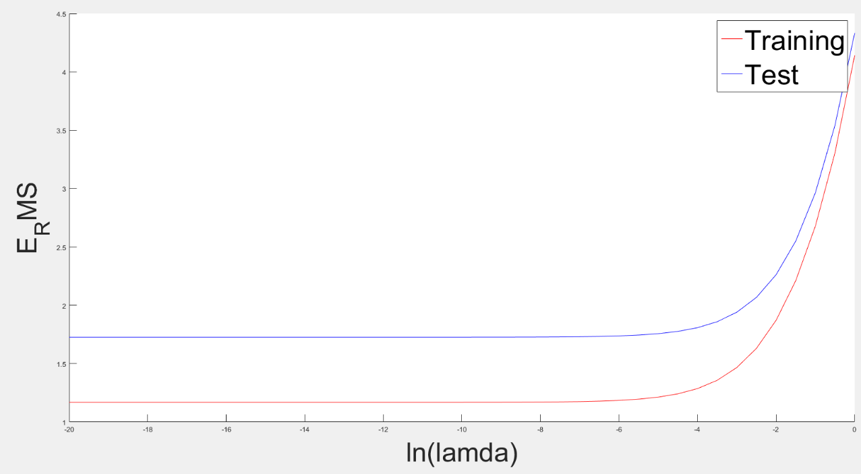

5.

(1)

M=1

Training : 0.2263

Test : 0.1711

M=2

Training : 0.1886

Test : 0.1532

(2)

少x1 : 0.2099

少x2 : 0.2088

少x3 : 0.2253

少x4 : 0.2138

0.2088最小，代表x2的貢獻最大